Property Symbols Used in the Adverts
 | Single Person
 | Couple
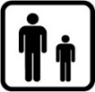 | Family with younger children
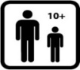 | Family with older children
 | Family with no dependant children
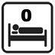 | The number of bedrooms in the property
The property advertised is sheltered or
extra care sheltered housing
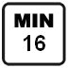 | The minimum or maximum age that an applicant must be to apply for the property (age restriction will be displayed within the icon when viewed on the Property website or the Newsletter)
 | Pets allowed/pet restrictions
 | The property has a garden
 | Off road parking is available at the property
 | The property is wheelchair accessible or has been adapted and priority will be given to households assessed as needing these adaptations.
 | Key worker only
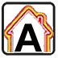 | Energy Efficiency
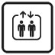 | Lift available
 | Affordable Rent
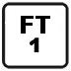 | Fixed Term Tenancy
 | Car free scheme

